

The VSP Direct

Payment Process in detail

Author: | Mat Peck
Creation Date: | Monday, 30 July 2001
Version: | 1.1
Last Modified: | Friday, 28 June 2002
Modified by: | Mat Peck

Security Rating: Public.
Distribution List: PROTX Staff, Customers and Contacts.

Table of Contents

1: Introduction 1
2: The Step-by-Step Payment Process 1
2.1: Customer selects good/services at the Vendor Website 1
2.2: Customer enters their Card Details on the Vendor site 2
2.3: Vendor Server sends an HTTPS post to VSP Direct 3
2.4: VSP Direct validates the POST 4
2.5: The VSP requests Authorisation from the Banks 5
2.6: VSP Direct replies to the Vendor’s HTTPS Post 6
2.7: VSP sends daily Batch file to initiate payments 7
3: Other VSP Direct Messages 8
3.1:PREAUTH requests 8
3.2: DEFERRED payments 8
3.3: RELEASE deferred payment 9
3.4: REPEAT payments 10
3.5: REPEATDEFERRED payments 11
3.6: REFUND requests 11

1: Introduction

This document explains, in detail, the VSP Direct payment process and the interaction between the Vendor website and Protx. The details are for VSP Direct only, please refer to other documentation for VSP Form, VSP Server and VSP Wallet.

NOTE: Original the protx VSP Server product was called the “Verified Payment System” and was referred to by the acronym VPS. When the product expanded to support a variety of interfaces, the name was changed to reflect the type of interface used. When reference is made to VPSTxID or VPSProtocol, these are not spelling errors since these field names date back to the original system. In the main text of the document, VPS and VSP are used interchangeably.

This document is intended for general distribution.

2: The Step-by-Step Payment Process

This section illustrates a typical online payment through the VSP System.

2.1: Customer selects good/services at the Vendor Website
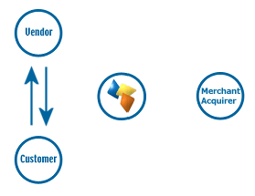
The customer interacts with the Vendor web site in the usual manner, filling a shopping cart with products, or electing to pay for a service of some description.

The Vendor site will calculate the price of the goods, obtain customer details (such as name, delivery address etc.) and present the user with a final confirmation screen, asking if they wish to proceed.

If the customer elects to continue they will be forwarded to the payment page on the Vendor's secure server.

2.2: Customer enters their Card Details on the Vendor site
Unlike VSP Server, where the customer is redirected to the protx site to enter their details, the VSP Direct model requires the Vendor to take the card details from the customer and pass them on to protx in a secure server-to-server POST.

Whilst this has the advantage of making the transaction registration much more simple (removing the need to redirect the customer anywhere, and the need for call-back messages and signatures), VSP Direct does require that the Vendor has their own valid 128-bit SSL certificate with which they can secure the card entry screens. Customers will not enter their card details on an unsecured page (in fact, card scheme rules insist that all such information is only passed over a secure channel) so the Vendor MUST maintain a valid certificate with a trusted third party supplier like VeriSign.

Once the card details have been taken and customer clicked the final submit button, the Vendor may wish to perform cursory checks (like LUHN checks or perhaps even fraud screening) using those card details. If the Vendor is happy with the information supplied by the customer, a script on the Vendor’s server builds an authorisation request to send to the VSP Direct servers in accordance with the VSP Direct protocol (see next step).

2.3: Vendor Server sends an HTTPS post to VSP Direct
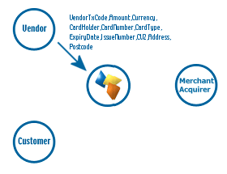
A script on the Vendor server builds and sends a secure POST (HTTPS) to the protx server, requesting an authorisation.

The script begins by generating a totally unique reference for this transaction. This must be different from ALL other transaction codes used by the Vendor’s system (even if it is for the same goods or same customer). It must also differ from codes used for refunds. This unique reference can be as simple as an incremental number, but many vendors use combinations of numbers, characters, date and time and so forth, to ensure the code is unique.

The POST must also include the Vendor Name, to identify them with the VSP, the total value of the purchase, the currency, a description of the goods, the cardholder’s name and the card number, type and expiry date (with issue number where appropriate).

If the vendor wishes to use Address Verification (AVS) and Card Verification Value (CVV2 or CV2) checks (please see additional protx documentation), the customer’s address, postcode and CV2 value will also be submitted in this post.

HTTPS POSTs are encrypted messages, encoded using protx’s 128-bit Global certificate, and sent to port 443 on our web server. This document will not describe HTTPS POSTs in detail, but what is important to this discussion is that the vendor can be assured that no-one but Protx will be able to decrypt the message, and nothing Protx send back in the reply to that POST can be decoded by anyone except the vendor. Even if someone were to capture ALL the information sent in a 128-bit encrypted session, it would take all the computers in the world longer than the lifetime of the universe to break the encryption.

In a Win32 environment the HTTPS posting for VSP Direct can be simplified by using the COM objects (Component Object Model, a Microsoft standard) that protx provide. This makes integration very simple.

In Unix environments, protx recommend the use of open standards, like OpenSSL (see www.openssl.org), which can be installed on Unix variants to allow the server to make HTTPS posts (although you will require root privileges to install it).

If your servers are hosted and maintained by a third party, you should check with them that you can install the COM objects or add UNIX system components. Many hosting companies now include OpenSSL as a standard on their UNIX servers.

2.4: VSP Direct validates the POST
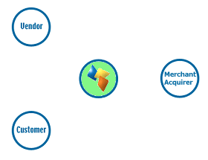
On receipt of the Vendor POST, the VSP begins by validating its contents. It first checks to ensure all the required fields are present, and that their format is correct. If any are not present or contain the wrong type of data, a reply with a Status of MALFORMED is generated, with the StatusDetail field containing a human readable error message. This normally only happens in the development stage (see step 2.6 for further information about replies).
If all fields are present and correct, the information in those fields is then validated. The Vendor name is checked against a pre-registered set of IP addresses, so VSP Direct can ensure the POST came from a recognised source. The currency of the transaction is validated against those accepted by the Vendor. The VendorTXCode is checked to ensure it has not been used before. If any of the information does not check out, a reply with a Status of INVALID is sent back to the vendor, again with a human readable error message in StatusDetail.

The card details are then validated with LUHN checks, IIN number checks which validate the card is of the specified type and expiry date checks to ensure the card has not expired.

If everything in the original POST checks out, the transaction is registered with the VSP and a new transaction code is generated that is unique across ALL vendors using the VSP systems, not just unique to that specific vendor. This code, the VPSTxID, is sent back to the vendor in the reply stage (see step 2.6).

If the information supplied is all correct, the card information is passed into the authorisation process (see step 2.5). If anything is incorrect, the authorisation step is bypassed and an appropriate reply generated by VSP Direct (see step 2.6)

2.5: The VSP requests Authorisation from the Banks
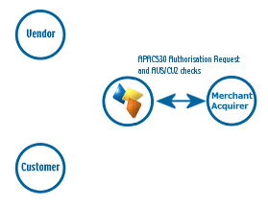
The VSP Direct system sends an internal secure message from our front-end processing systems to the back-end authorisation boxes, over our own secure private network.

The VSP authorisation services then format an APACS30 message and send the request to the Vendor’s merchant acquirer over the X25 banking network.

The request is normally answered within a second or so with either an authorisation code, or a failure message.

The VSP system treats all failures in the same way, ultimately replying to the Vendor with a NOTAUTHED message and a blank authorisation code.

If the acquirer does return an Auth code, VSP Direct prepares an OK response for the vendor (next step)

If AVS and CV2 checks are being performed, the results are compared to the rule base set up for the vendor. If the bank has authorised the transaction but the card has failed the AVS and/or CV2 checks, protx immediately reverse the authorisation on the card and prepare a NOTAUTHED response for the vendor, returning the reason for the failure in the AVSCV2 field (next step).

2.6: VSP Direct replies to the Vendor’s HTTPS Post
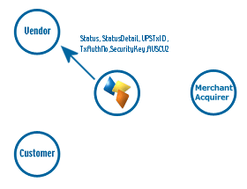
Because VSP Direct is an entirely synchronous POST-RESPONSE protocol, information about the success or failure of the authorisation is passed back as a response to the Vendor’s original HTTPS post (i.e. the POST’s REQUEST object is completed by the vendor in step 2.3, then the RESPONSE object is filled out by the VSP system in this step. The same script on the Vendor’s server can handle the POST and RESPONSE, with no call-back URLs required)

The response object contains a Status field that holds either “OK”, if the transaction was authorised at stage 2.5, “NOTAUTHED”, if the authorisation failed, or “MALFORMED” or “INVALID” if information in the POST was missing or incorrect (see step 2.4). (There is actually a 5th condition, “ERROR”, but that only occurs when something serious has occurred at Protx, for example database failure, or all X25 links down)

The Vendor normally only receives MALFORMED responses during development, since these errors indicate something is missing from the protocol.

An INVALID message indicates that some of the information supplied was not acceptable. The vendor’s site should communicate to the customer that the information they supplied could not be validated and request the details again. If this persists the customer should be asked to call the vendor directly.

A NOTAUTHED message is returned if all the information supplied was correct, but the merchant acquirer did not authorise the transaction, either because the user’s card has exceeded spending limits, or is present on a stolen card list, or (if the Vendor is registered for AVS and CV2 checks) because the additional checks failed to satisfy the vendor rule base. Customers should be asked to enter alternative payment details.

An OK message means the transaction has been authorised successfully. The message will contain the unique ID for this transaction (the VPSTxID), an encryption key (SecurityKey) and an authorisation code (TxAuthNo).

OK and NOTAUTHED messages will contain AVSCV2 information if those checks are enabled for the vendor.

The Vendor should store the VPSTxID, TxAuthNo and SecurityKey against their own VendorTxCode in their database to allow the transaction to be refunded or repeated if desired (see section 3). This information is also, normally, associated with the shopping cart contents, so the Vendor server can retrieve all available order information easily.

The real time processing of the transaction by protx is now complete.

2.7: VSP sends daily Batch file to initiate payments
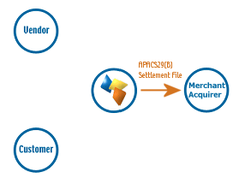
Once per day, at 2:10am, the VSP system takes all authorised transactions for each acquirer and creates an APACS29(B) format batch file.

Transactions for ALL vendors who use the same merchant acquirer are included in this file i.e. it is not vendor specific.

The file is uploaded over File Transfer Protocol (FTP) via either an ISDN or PSTN connection with the bank.

If the file does not transmit correctly, the system tries a further nine times at 10-minute intervals. If all 10 attempts fail, the transactions for that bank are released and included in the following day’s batch instead. protx monitor each day to ensure the file has been sent, and if not, the service department correct the problem during the day to ensure the file is sent correctly that evening.

The acquirers send summary information back to protx to confirm receipt of the file, but in many cases protx have to wait for the acquirers to send paper confirmation through the post to check that the file was accepted and no transactions were rejected.

3: Other VSP Direct Messages

The steps described in the above sections explain the process of registering a new payment transaction with the VSP Direct. This section outlines the other types of message that can be sent from the Vendor server to protx, to accomplish additional payment related tasks.

3.1: PREAUTH requests

PREAUTH requests are made in exactly the same manner as normal payments (steps 2.1 to 2.6 above). PREAUTHs, however, do not move any money from the customer account to the online merchant. This request merely validates the card, checks that it has sufficient funds to support the transaction, obtains an auth code, and then immediately reverses the transaction so that the customer is not left with an outstanding shadow on their card.

This transaction type is very useful for merchants who wish to create online accounts. The user’s card can be validated but not charged when the account is set up, then charged for goods and services at a later date using the REPEAT payment request (see 3.4 below) without the need for the customer to re-enter their card details.

3.2: DEFERRED payments

DEFERRED payments are registered in exactly the same manner as normal payments (see stages 2.1 to 2.6). The only difference is that deferred payments are not automatically settled that evening (step 2.7) but are instead held in a queue until a message is received from the vendor server releasing the payment (see step 3.3).

Deferred payments are useful in situations where the online merchant wishes to validate the customer’s card but does not wish the funds to be committed until the goods are shipped.

NOTE: When a card is authorised a shadow is placed on the cardholder’s account. This marks the payment against the account and prevents the user from spending that money before the settlement file is received. This shadow is always valid for 24 hours, but for some cards cannot be guaranteed after that. If the shadow has expired and the settlement file received, the money will still be transferred if sufficient funds exist. If they do not, however, the authorisation is rejected. Merchants who wish to use deferred payments should bear this risk in mind. protx recommend using a PREAUTH (see above) to validate the card, then a REPEAT payment (see 3.4) when the goods are about to be shipped. If the REPEAT payment fails the goods can be held back until the customer is contacted.

3.3: RELEASE deferred payment
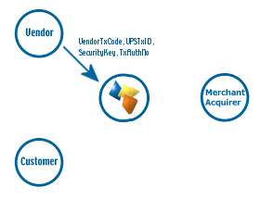
DEFERRED payments (see 3.2) and REPEATDEFERRED payments (see 3.5) are not settled (and hence funds are not transferred) until a RELEASE message is received. The release message is a server-to-server HTTPS POST containing the transaction type “RELEASE” and the VendorTxCode, VPSTxID, SecurityKey and TxAuthNo of the original deferred payment.

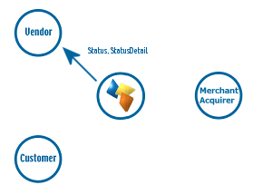
The VSP Direct replies to the Release message with a Status and StatusDetail field giving the outcome. A status of “OK” indicates a successful release of a deferred payment. The referenced transaction will be included in the daily batch file sent the following morning.

“INVALID” will be returned if the referenced transaction is already released, or not a deferred payment in the first place.

“MALFORMED” is normally only returned during development and indicates the release request was poorly formatted. “ERROR” is reserved for problems within protx itself.

3.4: REPEAT payments

REPEAT payments are a convenient means of charging additional amounts to a customer who has already made payments on a merchant’s site, without the need to request the customer’s card details again. The card details are already known by the VSP system through reference to the previous transaction.

The original transaction can be ANY type of VSP Direct transaction (i.e. a PAYMENT, a DEFERRED payment, PREAUTH or even a previous REPEAT payment) as long as it was authorised. The REPEAT request does not actually repeat the original transaction; it merely makes a further request for payment against whichever card was used to perform the original transaction. So, for example, a common use of the repeat payment is for vendors to PREAUTH the card when the user creates an account, then request a REPEAT payment against the initial PREAUTH when they actually wish to charge for something.

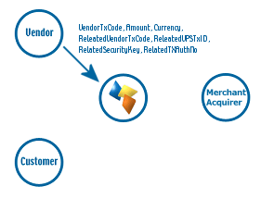
To make a repeat payment, the vendor needs to supply the VendorTxCode, VPSTxID, SecurityKey and TxAuthNo from the original transaction, along with the repeat payment information (i.e. the amount, currency, and VendorTxCode for this new transaction) in a server-to-server HTTPS POST

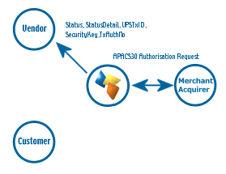
A new transaction is created by VSP Direct, the card details from the original transaction extracted and the card charged with the amount specified.

If the transaction is successful a new TxAuthNo is returned, along with a VPSTxID and a SecurityKey. These should be stored by the vendor alongside the VendorTxCode for this transaction so that this too can be REPEATED if desired, or REFUNDED if necessary (see 3.6)

The Status and Status detail fields, as always, contain human readable error information in the event of a failure.

AVS and CV2 information is not checked for a repeat payment, since it is assumed that such checks must have been passed in the original payment for a TxAuthNo to have been returned, so additional checks are surplus to requirement.

3.5: REPEATDEFERRED payments

A REPEATDEFERRED payment is exactly the same as a repeat payment except (like a DEFERRED payment, see 3.2) the funds are not committed immediately. Instead the transaction is held in a queue waiting to be settled until a RELEASE message is received (see 3.3). Like normal REPEAT payments, the original transaction referenced in this request does not have to be an earlier REPEATDEFERRED request, but can be any authorised transaction (be it PREAUTH, PAYMENT, DEFERRED etc.)

3.6: REFUND requests

To request a refund the vendor must supply the unique reference codes and auth code of the original successful payment, along with the amount to refund. The original transaction can be either a standard PAYMENT, or a DEFERRED payment that has already been RELEASED, or a REPEAT or released REPEATDEFERRED payment. The refund method is identical irrespective of the payment type.

A vendor can make any number of refunds against an original purchase transaction as long as the total amount refunded does not exceed the amount of the original payment.
To make a refund, the vendor needs to supply the VendorTxCode, VPSTxID, SecurityKey and TxAuthNo from the original transaction, along with the refund information (i.e. the amount, currency, and VendorTxCode for this refund) in a server-to-server HTTPS POST

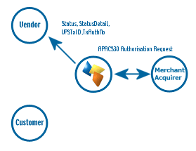
A new transaction is created by VSP Direct, the card details from the original transaction extracted and the card refunded with the amount specified.

If the refund is successful a new TxAuthNo is returned, along with the VPSTxID of this new transaction.

The Status and Status detail fields, as always, contain human readable error information in the event of a failure.

